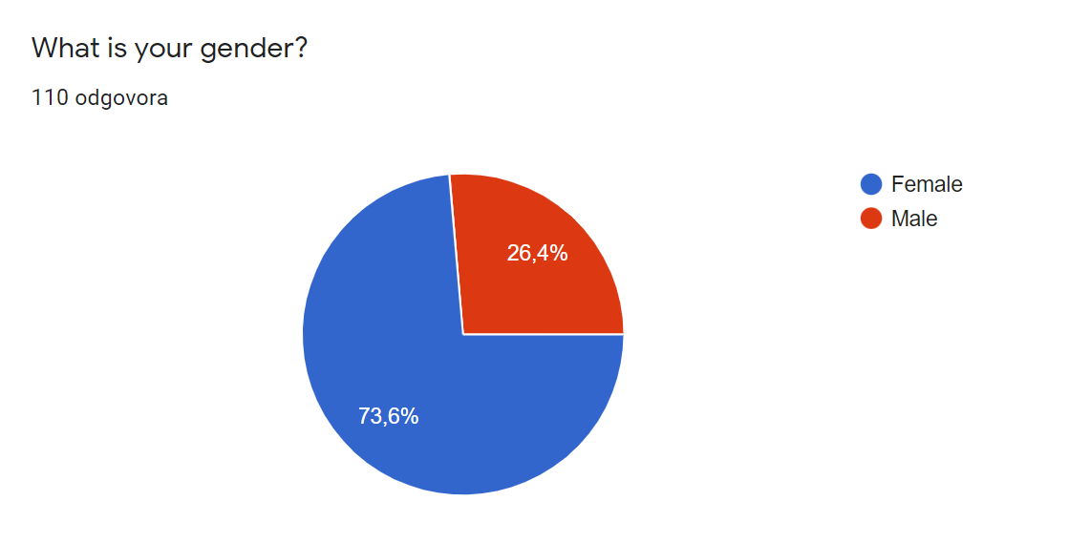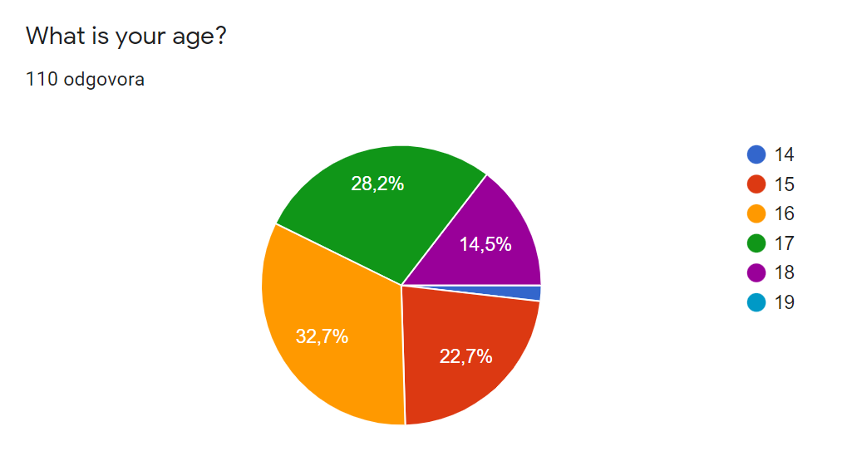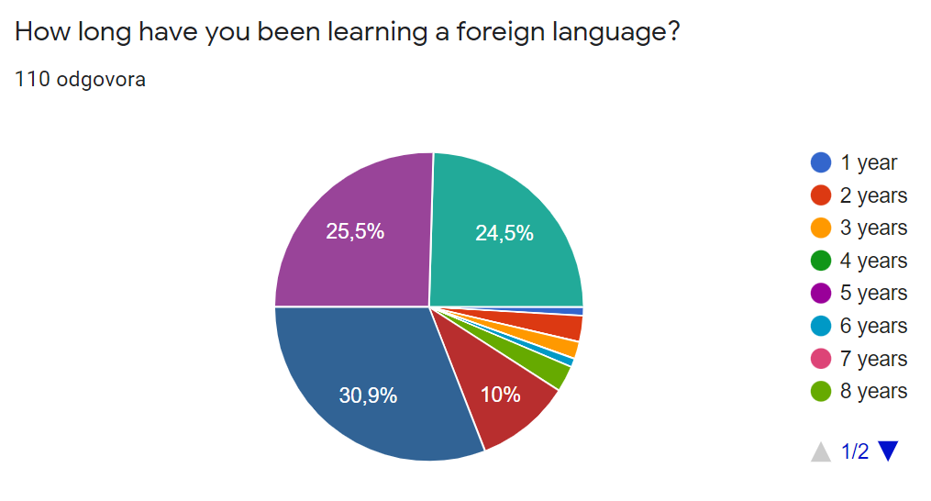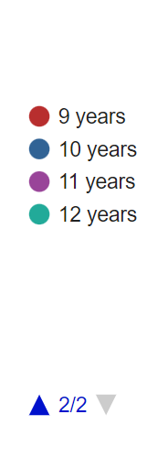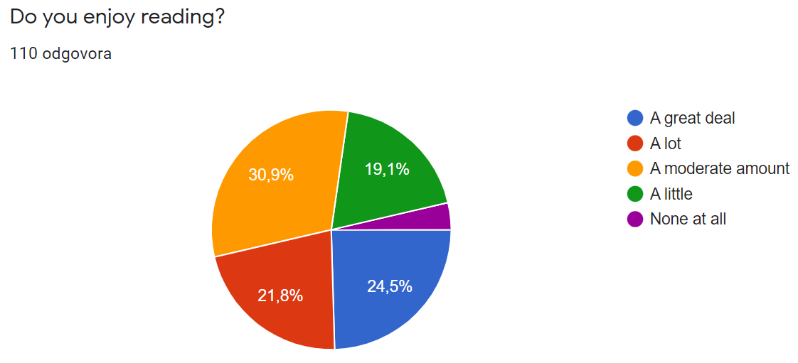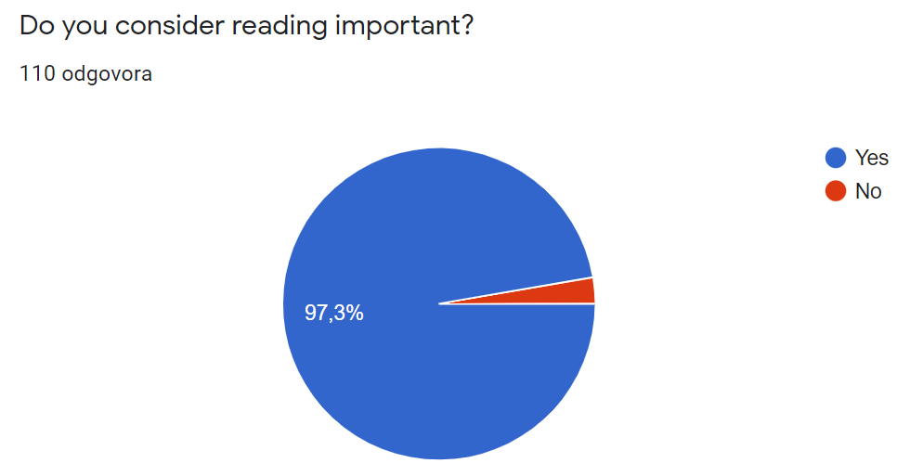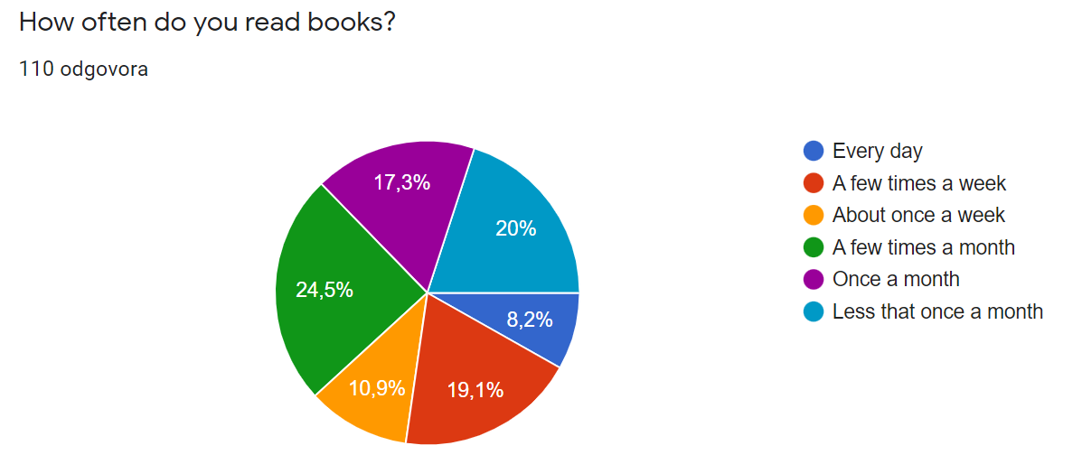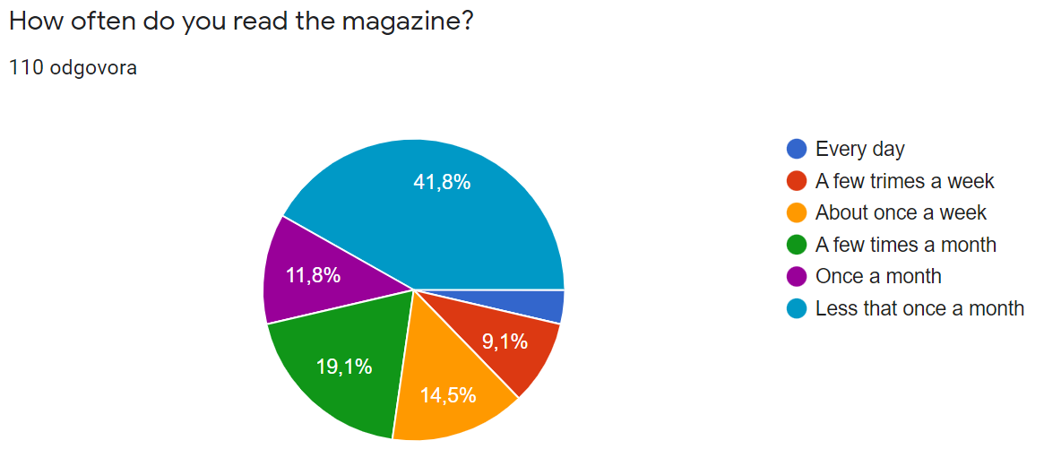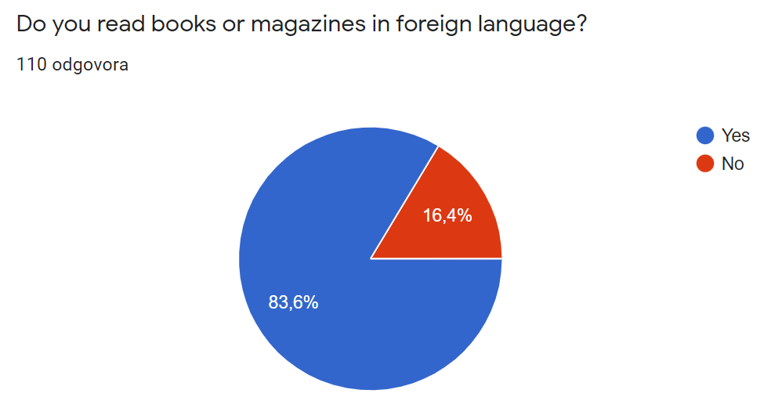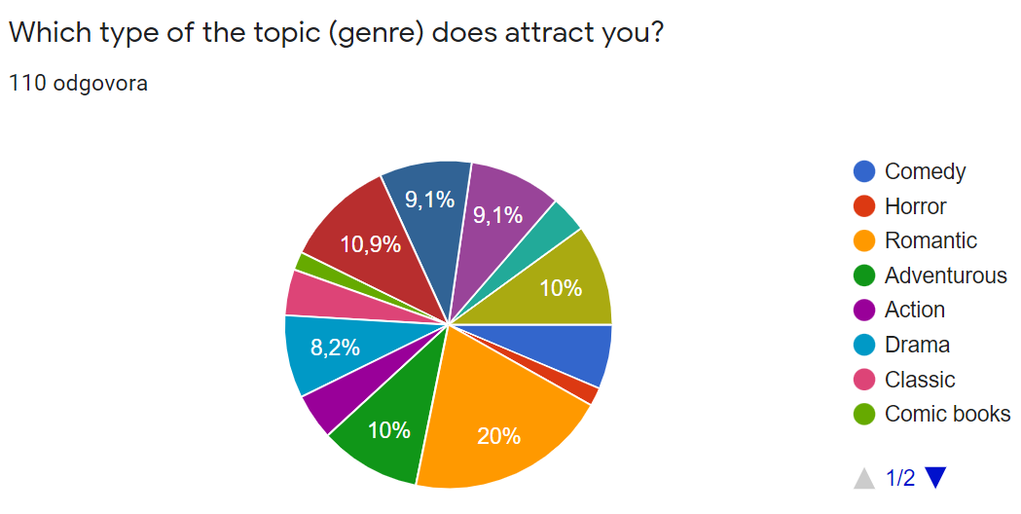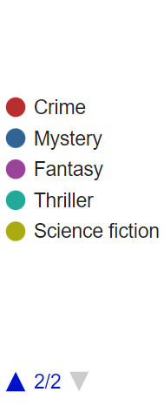
1.9%
2.7%
1.8%
0.9%
3.7%
2.7%
3.7%
3.6%
1.8%
3.6%
6.4%
4.5%
4.5%
1.8%
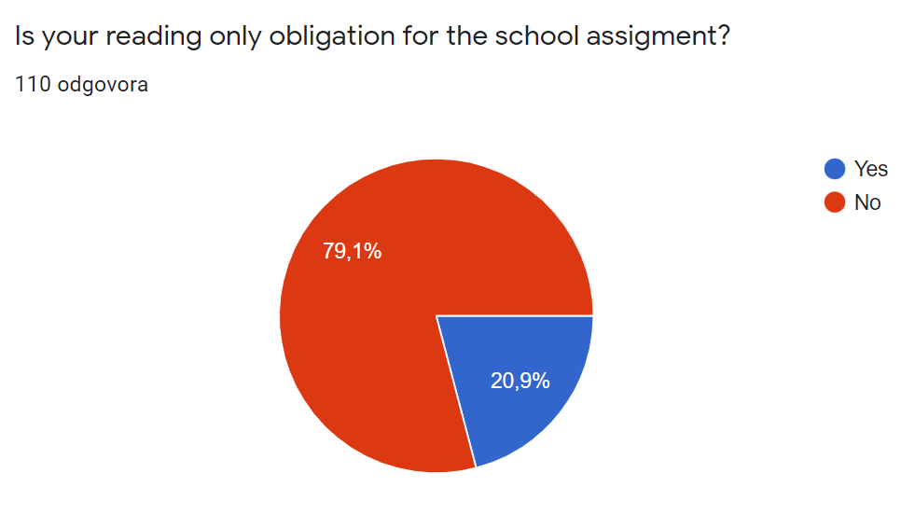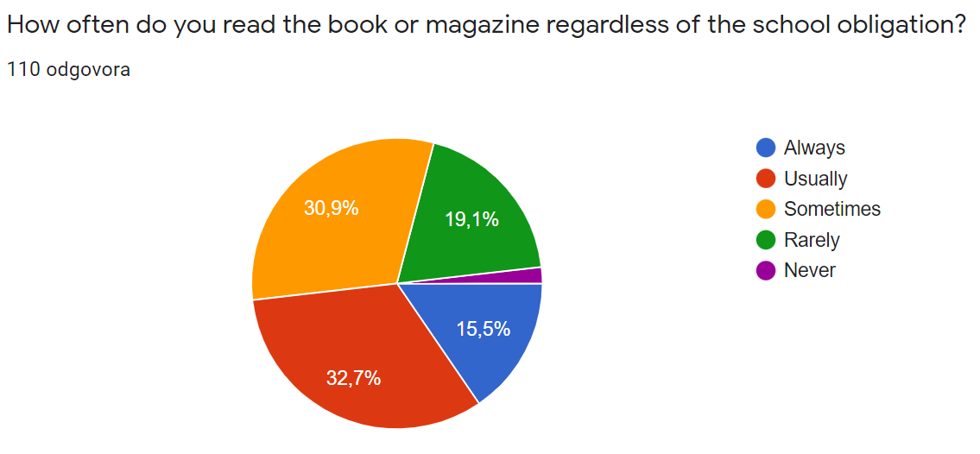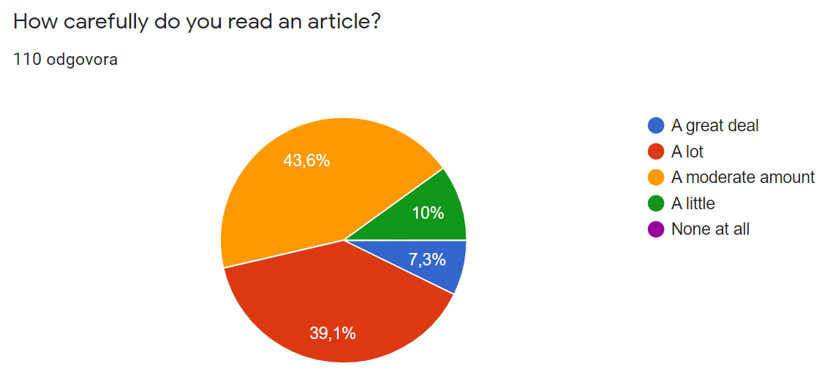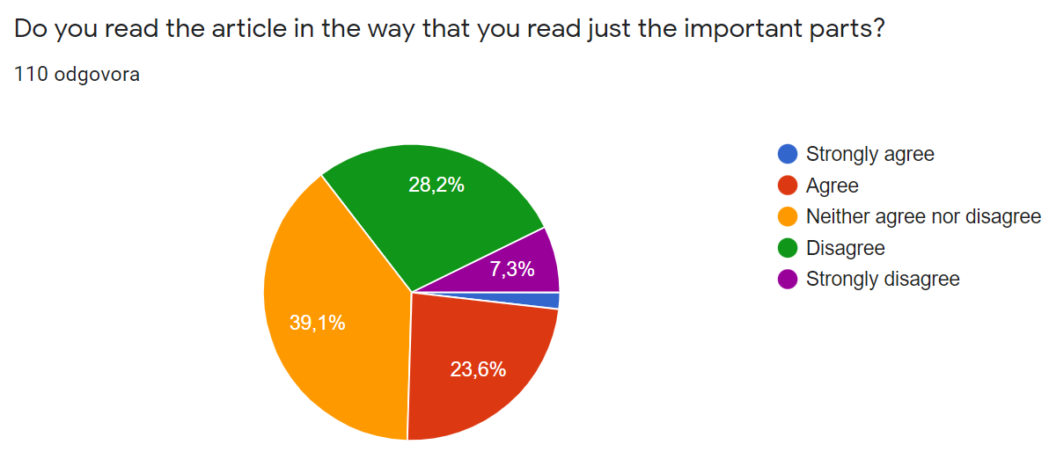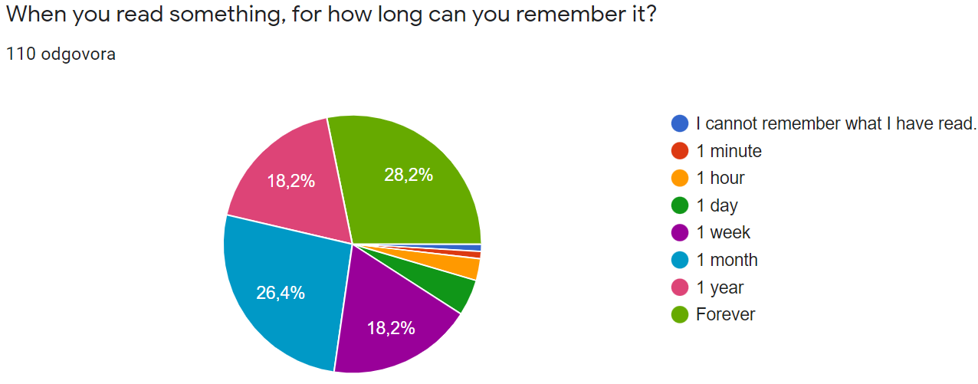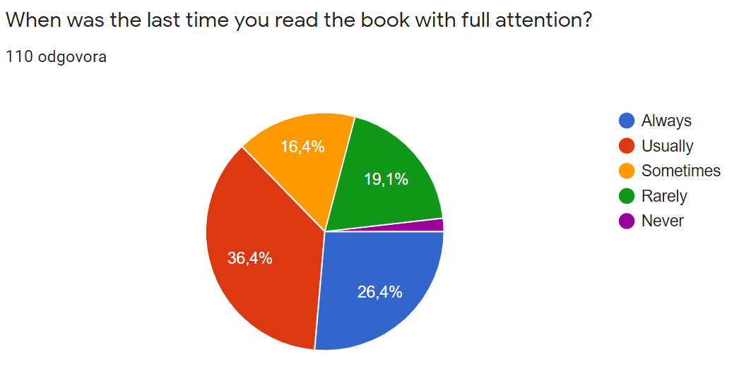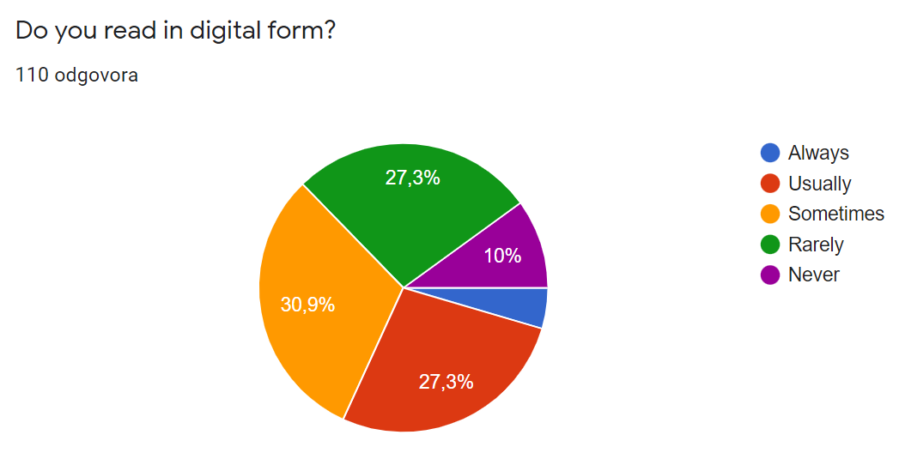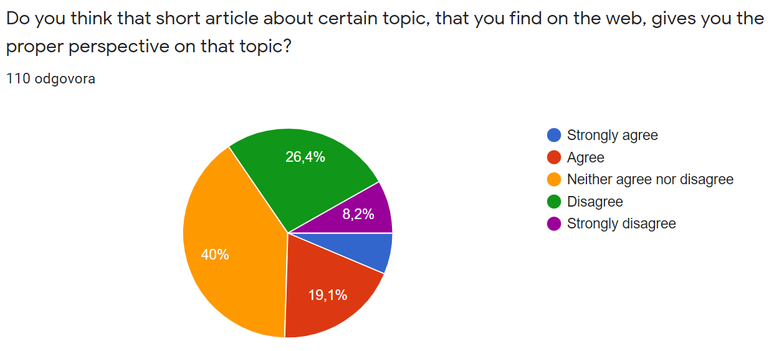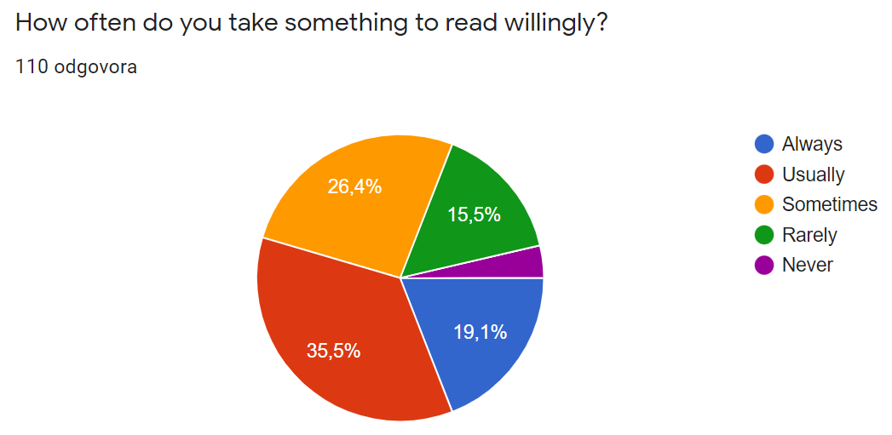
1.8%
1.8%
2.7%
4.5%
0.9%
1.7%
4.5%
6.3%
3.5%
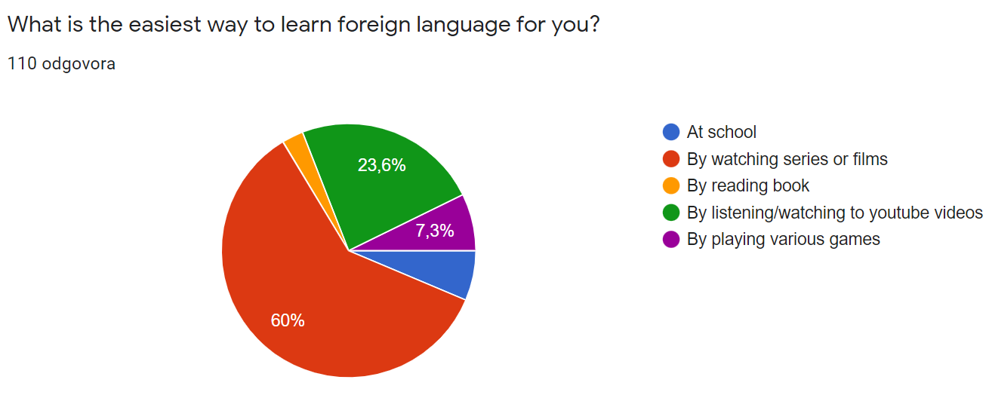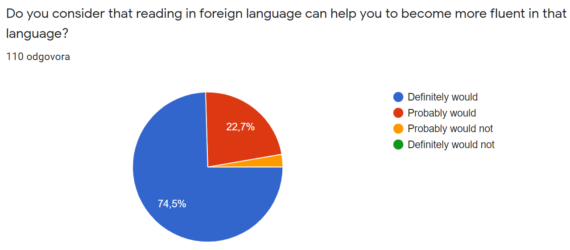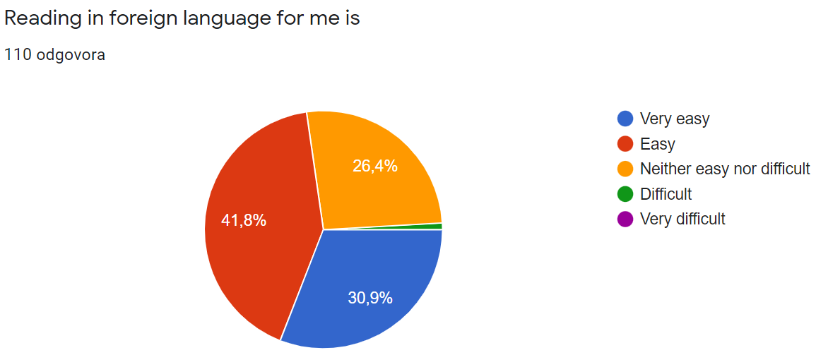
6.4%
2.7%
2.8%
0.9%

Why is reading important?
It helps us to learn new words and expressions.

Reading gives you a great vocabulary.

We learn a lot through reading. When i was younger i enjoyed reading more, but now I don't really have time for it. We expand our vocabulary through reading.

We learn through reading.

Reading expands our imagination and our vocabulary.

I think it helps you to understand your thoughts, other cultures, some situations, emotions and spreads your vocabulary.

Reading expands our vocabulary.

Books are a source of knowledge that internet and movies can’t give us. They give our imagination a choice to picture scenes and characters the way we want.

I think that reading is important for expanding our vocabulary or learning about different life situations or cultures.

Reading is important because it increases our imagination and helps with memory as well as acquiring knowledge.

It helps improve your vocabulary.

Reading gives you different perspective on some topics, helps you develop critical thinking, improves your vocabulary and it is a great way to escape the reality when it gets too difficult sometimes.

Čitanjem se educira.

I think that reading is important because that is how we develop our view of the world, separate good from bad and we get to know ourselves.

I believe reading is important because by reading you expand your vocabulary.

Reading widens your vocabulary and your imagination.

I think that reading is very important because when we read we improve and upgrade our vocabulary, learn about new things, improve knowledge about world. Also we learn new words and we can use it when it is spoken to make conversation much better.

Because we expand our knowledge.

It is important for us to expand vocabulary.

I think it expands your vocabulary.

To keep our minds young and healthy.

I think reading is very important as it expands our vocabulary and it also teaches us many things (depending on the book we are reading).

I think reading is important because it improves my vocabulary and knowledge about certain topics.

It is important in order to gain critical thinking and to expand our vocabulary.

I think that reading is very important because it enriches the vocabulary and develops imagination.

Reading encourages me to think about things, ideas, situations that I wouldn't otherwise think about, in other words it broadens my perspective of the world.

I think that reading is a great way to make good use of free time, not only is it relaxing, but also it emproves vocabulary and expands knowledge, because you can learn a lot of new concepts and of course with all this, almost every book can teach us some lesson that can turn out useful later in life.

Reading is important because it teaches us how to properly express our thoughts, learn something, learn vocabulary.

We develop our thinking and concentration better than on mobile devices.

Reading is good form of learning and reading can expand our imagination.

It's good chance to read a book from time to time. For me, it just helps me to relax and just cool off.

I think reading is important because it helps expand your vocabulary and it can help you learn about other people's experiences and cultures as well as various other topics.

I think it is important because you can learn more things and words.

It is a great way of learning new things.

Reading is important because it helps develop critical thinking.

I think that reading makes your creative thinking more developed and also helps improve concentration.

I think it is very important for our vocabulary and it is also very relaxing and fun.

It is important for practising language and for vocabulary.

I think it is important because you expend your vocabulary and you are more educated on some topic.

It spreads our vocabulary and it is plus for our thinking and development.

I find reading important because we can expand our vocabulary and we can also learn things about life.

I think that it is important because we learn a lot of things while reading.

Reading is important for your general knowledge and way of thinking.

It is important for our development.

By reading we increase our vocabulary and look at the things more openminded.

I think it improves our knowledge of words and the use of them.

Reading improves our vocabulary.

I think that reading is very needable. In my opinion there should be a lot more books with a nice coverage to actually interest the kids into the reading.

It can expand our vocaboulary.

Your vocabulary gets much better.

Reading is very important because it improves vocabulary and speaking skills.

It expands our vocabulary and can give us other perspectives on certain topics.

Reading expands vocabulary and strengthens character.

You can learn new words.

Improves our vocabulary.

Reading is important beacuse it improves our concentration.

I consider reading very important because you get to expand your vocabulary a lot. You can also learn a lot while reading, I just have never been a fan.

It develops the mind. The mind is a muscle. It needs exercise.

I think reading is very important for learning new words.

Because you become more fluent in that language.

To expand your vocabulary.

I think reading is important but i don't like it.

We expand our vocabulary that way.

Because it expands your vocabulary.

It helps develop our vocabulary.

It enriches people in every way.

Expands vocabulary.

We learn new words and make our vocabulary better.

It’s important for education.

Mislim da se pomoću čitanja možemo naučiti bolje izražavati te da nam čitanje povećava vokabular.

Čitanje je važno jer povećava vokabular i pomaže u boljem razvijanju mozga kod djece.

Reading is important. It helps us to form different opinion and makes it easier to comunicate with the world. By reading you can find out about other lives and interesting stories. It helps as to relieve boredoom.

Jer je zabavno i razvija nam maštu.

Expanding your vocabulary, learning new things.

Mislim da je čitanje važno kako bi se poboljšao vokabular i kako bi se moglo naučiti nešto novo.

Firstly it is great for expanding your vocabulary and secondly books in general take you to another world and you have fun reading it, if the subject satisfies you.

Reading is important for vocabulary expansion.

Expands dictionary.

Mislim da je čitanje jako važno iz mnogo razloga kao što su: proširivanje vokabulara, poticanje mašte, kreativnosti, edukacija.

Reading involves one's mind, broadens vocabulary and lets you lose yourself in a world other than this everyday one.

Mislim da naš vokabular najviše razvijamo čitanjem, pa je stoga jako bitno čitati.

It makes your vocabulary rich, improves your imagination and you learn a lot new things.

Reading is a good way to learn new words and frases.

It’s very important for our vocabulary and imagination.

It builds character and expands our vocabulary.

Reading especially in foreign languages can expand your vocabulary!

Helps with developing your brain.

Your vocabulary is rich when you read sth.
.
Vocabulary grows.

It helps improve our knowledge and imagination.

I think that is important because in that way we are making richer vocabulary.

Reading is important wether you read in a foreign or your mother tongue language. It expands vocabulary and ability to express our thoughts and opinions clearly. Also it can help with learning a foreign language.

Čitanje nam pomaže proširiti vokabular i opušta nas.

Kroz čitanje se poboljšava naš vokabular te se učimo stručnije izražavati.

I think reading really expands our vocabulary and our way of thinking/viewing certain things or situations.

I consider reading very important because it helps improve your vocabulary, but that’s not why I read. I love reading because I get a break from a real world, it can take me anywhere.

It expands our knowledge and vocabulary.

Better vocabulary

Yes,because it gives you both,pleasure and knowledge.

